
8 Aug 2019

ITRW 321 Assignment 2 Requirements Analysis
Group 1 – The Nerd Herd
Alwyn Barnard (Group leader) 28430093
Anerique van der Walt 28467078
Welmari Odendaal 28975383
Sarina Haasbroek 27035824

Table of Contents
1. Information Needed for Business Decisions 2
2. Different Levels of the Organization for which Information is Needed 3
3. Different Business Areas of the Organization for which Information is Needed 5
4. Format of Information Needed 7
5. Timespan Required for Information 11
6. Aggregation Needed & Granularity (Different Levels of Aggregation Needed) 12
7. Dimensionality 13

1. Information Needed for Business Decisions

 | BUSINESS DECISION | BUSINESS INFORMATION NEEDED
1 | An artwork can only be sold once. | Which artwork has been sold, on display and not for sale?
2 | More than one artwork can belong to a collection. | List of current collection. What artwork exists in a collection.
3 | To create a new collection there needs to be at least one artwork in the collection. | What is the new collection name and what artwork will be added to that collection?
4 | An artwork exists of at least one medium | What medium is used to create the artwork.  (Medium – The material used to create the artwork example such as canvas or clay)
5 | A medium need to be used on at least one artwork for it to be added to the database. | What medium is used for an artwork and check if it already exists in the database.
6 | An artist can have more than one collection. | What artwork was created by which artist and in what collection does the artwork belong to.
7 | An artist must have at least one collection. No artwork without a collection will be accepted | Checks the collection and their corresponding artist.
8 | An artist needs to have a bank account for payments. No cash will be paid on transactions | Retrieve the artist’s banking details, such as bank and account number.
9 | At least one bank needs to be used by an artist to be added in the database | Retrieve the artist’s banking details.
10 | At least one city needs to be lived in by an artist to be added in the database | Retrieve the artist’s address details, such as street number, city and postal code.
11 | At least one artwork needs to be sold to get a sales transaction detail (Receipt). | Retrieve artwork information and client details for receipt.

2. Different Levels of the Organization for which Information is Needed

LEVELS | PARTICIPANTS | INFORMATION NEEDED
Level 1 (Managerial level) | Gallery owner | The gallery owner must have access to all data stored. He/she will also have access to the different departments’ data  The owner will also have additional access to generate specific reports and historical data, to make important business decisions.
Level 2  (Specialized Managerial Access) | Gallery assistant | The gallery assistant will have practically similar access a gallery owner has, with one fundamental difference: The assistant cannot change reports or have access to any financial or accounting data.
Level 3 (Department-specific Managerial Access) | - Financial department  - Human Resource department  - Admin department  - Sales department  - Logistics department | The department heads (managers) will have full access to their specific department’s heads data and any supporting (but necessary) data needed for day to day business activities.  They will not have any unauthorized access to other departments.  Financial department:  Entire CLIENT, SALES_TRANSACTION, BANK, CITY, and ARTIST tables.  Admin department:  Entire CITY, CLIENT, SALES_TRANSACTION, ARTWORK, MEDIUM, COLLECTION, ARTIST, and BANK tables.  Sales department:  Entire SALES_TRANSACTION, SALES_TRANSACTION_DETAIL, ARTWORK, ARTIST, and MEDIUM tables.  Logistics department:  Entire CITY table.  CLIENT (Client_LName, Client_Initials, Client_Cell, Client_Email, Client_Street_Address, Street_No).  ARTWORK (Artwork_Title, Length_cm, Width_cm, Artwork_Status).  SALES_TRANSACTION (Delivery_Method).

3. Different Business Areas of the Organization for which Information is Needed

DEPARTMENT | INFORMATION NEEDED
Human Resource department | - Calculate the total amount of sales per salesperson  - Calculate the amount of sales per artist/collection  - Calculate Salaries of all employees  - Calculate commission for each salesperson  The Human Resource Department is responsible for all staff payments and dealing with all sales and expenses related to employees.
Logistics department | - Dispatching delivery drivers to delivery locations  - Handling all deliveries and shipping of artworks.  - Storing artworks  - Packaging artworks and moving them between areas of the Museum.  - Physical maintenance of all artworks  The Logistics department manages all the commercial and logistical aspects of the Museum. They deal in maintain the artworks and shipping it to their new owners.
Admin department | - Dealing with all administrative work that the respective managers need to be handled.  - Adding and removing Artists, Clients, Artworks, Banks, Collections, Transactions, Mediums  The Administrative department deals with all administrative duties, documentation etc.
Sales department | - Selling artwork  - Acquiring artwork  - Acquisitions  - Dealing with Artists and Clients  The Sales department deals with selling and acquiring artwork and artists.
Financial department | - Calculate the total amount of expenses for each department and time frame specified.  - Report on expenses versus sales  - Report on salaries per salesperson and staff.  The Financial department covers all the financial areas and duties of the business and deals with all finance related reporting.

4. Format of Information Needed

Required information scenario 1: Display total sales transaction per year per month per artist.
USER\USERS | DISPLAY FORMAT | INFORMATION EXTRACTED
Managerial level - Gallery owner | - Use a column chart to visually display sales figures per year.  - The user can click on any column  - Then the drill down can then be used to display the sales transaction of that year on a line chart with monthly intervals.  - The user can then click on any month interval.  - The drill down then displays the sales transaction of that month on a pie chart with artist intervals (This shows whose artist artwork was sold that month). | The gallery owner will be able to extract historical data so that the he can compare the sales figures with previous ones.
Specialized Managerial Access - Gallery assistant |  | The gallery assistant will only be able to view the extracted information.
Department-specific Managerial Access – Financial department, Sales department |  | The financial and sales department will only be able to view the extracted information for financial purposes.

Required information scenario 2: Display the top 10 artist per year per month.
USER\USERS | DISPLAY FORMAT | INFORMATION EXTRACTED
Managerial level - Gallery owner | - Use a cluster column chart to visually display top 10 artist per year.  - The user can click on any column  - Then the drill down can then be used to display the selected artist of that year on a line chart with monthly intervals. | The gallery owner can see which artist’s work is in high demand.
Specialized Managerial Access - Gallery assistant |  | The gallery assistant will only be able to view the extracted information.
Department-specific Managerial Access – Admin department, Sales department |  | The admin and sales department will only be able to view the extracted information for inventory purchases.

Required information scenario 3: Display the top 5 devoted clients per year per month.
USER\USERS | DISPLAY FORMAT | INFORMATION EXTRACTED
Managerial level - Gallery owner | - Use a cluster column chart to visually display client (those who spent the most money) per year.  - The user can click on any column  - Then the drill down can then be used to display the selected client of that year on a line chart with monthly intervals. | The gallery owner can see which artist’s work is in high demand. The gallery owner can this way get to know his/her client.
Specialized Managerial Access - Gallery assistant |  | The gallery assistant will only be able to view the extracted information.
Department-specific Managerial Access – Sales department |  | The admin and sales department will only be able to view the extracted information for inventory purchases. These department can use this information for targeted advertising.

Required information scenario 4: Display the top 15 medium per year per month.
USER\USERS | DISPLAY FORMAT | INFORMATION EXTRACTED
Managerial level - Gallery owner | - Use a cluster column chart to visually display the top 15 trending mediums per year.  - The user can click on any column  - Then the drill down can then be used to display the selected medium of that year on a line chart with monthly intervals. | The gallery owner can see which type (popular medium) of artwork is in high demand.
Specialized Managerial Access - Gallery assistant |  | The gallery assistant will only be able to view the extracted information.
Department-specific Managerial Access – Sales department |  | The sales department will only be able to view the extracted information. This department can use the information for advertising purposes and for new inventory purchases.

Required information scenario 5: Display the top 5 delivery locations(city) per year per month.
USER\USERS | DISPLAY FORMAT | INFORMATION EXTRACTED
Managerial level - Gallery owner | - Use a clustered column chart to visually display top 5 cities per year.  - The user can click on any column  - Then the drill down can then be used to display the selected city of that year on a line chart with monthly intervals. | The gallery owner will be able to view the extracted information.
Specialized Managerial Access - Gallery assistant |  | The gallery assistant will only be able to view the extracted information.
Department-specific Managerial Access – Logistic department |  | The logistic department will be able to generate the delivery list.  The drill down will make it possible to filter the information.

Required information scenario 6: Display the total income per year per month per artist
USER\USERS | DISPLAY FORMAT | INFORMATION EXTRACTED
Managerial level - Gallery owner | - Use a histogram chart to visually display the total income from sales per year.  - The user can click on any column  - Then the drill down can then be used to display the total income of that year on a line chart with monthly intervals.  - The user can then click on any month interval.  - The drill down then displays the total income of that month on a pie chart with artist interval. (This shows whose artist artwork was sold that month). | The gallery owner will be able to extract data that the he can compare the commission figures with previous ones.
Specialized Managerial Access - Gallery assistant |  | The gallery assistant will only be able to view the extracted information.
Department-specific Managerial Access – Admin department |  | The admin department will only be able to view the extracted information for financial purposes.

Required information scenario 7: Display the total debt per year per month per client.
USER\USERS | DISPLAY FORMAT | INFORMATION EXTRACTED
Managerial level - Gallery owner | - Use a histogram chart to visually display the total debt figures per year.  - The user can click on any column  - Then the drill down can then be used to display the total debt of that year on a line chart with monthly intervals.  - The user can then click on any month interval.  - The drill down then displays the total debt of that month on a pie chart with client interval. (This shows which clients has the most debt in that month). | The gallery owner will be able to extract data to view outstanding debt of clients.
Specialized Managerial Access - Gallery assistant |  | The gallery assistant will only be able to view the extracted information.
Department-specific Managerial Access – Financial department |  | The financial department will only be able to view the outstanding debt and make arrangements for collection.

Required information scenario 8: Display the total inventory per year per month per collection.
USER\USERS | DISPLAY FORMAT | INFORMATION EXTRACTED
Managerial level - Gallery owner | - Use a funnel chart to visually display the total inventory figures per year.  - The user can click on any horizontal bar.  - Then the drill down can then be used to display the total inventory levels of that year on a column chart with monthly intervals.  - The user can then click on any month interval.  - The drill down then displays the total inventory levels of that month on a histogram chart with collection interval. (This shown the total artwork still available in selected collection). | The gallery owner will be able to extract data to view inventory levels.
Specialized Managerial Access - Gallery assistant |  | The gallery assistant will only be able to view the extracted information.

5. Timespan Required for Information

TIME DIMENTION | INFORMATION IN THE TIME DIMENSION
Yearly | - Various reports are created at the end of the year, such as sales, client, artist and inventory to keep track of the gallery’s activities.  - The sales report at the end of the year will give the gallery owner an idea on how well the gallery performed during the year.  - The client and artist report will give the gallery owner an indication of how successful the marketing was for the year to recruit new clients and artist.  - Inventory report is mandatory for security purposes.
Quarterly | - The trending artwork needs to be captured, so that the museum can determine which type of artwork is in high demand. This will enable them to display artwork that sell fast.
Monthly | - The monthly sales and commission need to be captured at month end, so that the museum can compare their sales figures and commission to see if there is any inconsistencies or warning sighs.  - Monthly reports of client debt will enable the business to keep track of their finances and to make arrangements for outstanding debt collection.  - Inventory report needs to be generated each month and compared with the sales report for security (to ensures no artwork was stolen).

6. Aggregation Needed & Granularity (Different Levels of Aggregation Needed)

The SQL functions for each scenario will be shown in capital letters and divided by transaction or operation by numbers.
Required information scenario 1: Display total sales transaction per year per month per artist.
- Using the SUM function, the total sales of the Museum is calculated per year per month for each artist

Required information scenario 2: Display the top 10 artist per year per month.
- Using the SUM function, each artist’s sales will be calculated.
- Then they will be sorted in DESCending order per year per month.
- Lastly the first (top) 10 will be EXTRACTed.

Required information scenario 3: Display the top 5 devoted clients per year per month.
- Using the SUM function, each client’s purchases per year per month will be calculated.
- Then the results will be sorted in DESCending order.
- Lastly the first (top) 5 will be EXTRACTed.

Required information scenario 4: Display the top 15 mediums per year per month.
- Using the SUM function, each medium’s occurrences will be calculated per year per month.
- Then the results will be sorted in DESCending order.
- Lastly the first (top) 15 will be EXTRACTed.

Required information scenario 5: Display the top 5 delivery locations(city) per year per month.
- Using the SUM function, each location’s occurrences will be calculated per year per month.
- Then the results will be sorted in DESCending order.
- Lastly the first (top) 5 will be EXTRACTed.

Required information scenario 6: Display the total income per year per month per artist.
- Using the SUM function, each artist’s income will be calculated per year per month.
- Then the results will be sorted in DESCending order.

Required information scenario 7: Display the total debt per year per month per client.
- Using the SUM function, each client’s outstanding balances will be calculated per year per month.
- Then the results will be sorted in DESCending order.

Required information scenario 8: Display the total inventory per year per month per collection.
- Using the SUM function, each collection’s occurrence will be calculated per year per month.
- Then the results will be sorted in DESCending order.

7. Dimensionality
Required information scenario 1: Display total sales transaction per year per month per artist.
DIMENSION | DESCRIPTION | POSSIBLE ATTRIBUTES
Time  - Year  - Month  Artist | - Year and month don’t require additional dimension table  - Artist required addition dimension table, because more info is required from artist than just the Artist_ID | Shown in table below
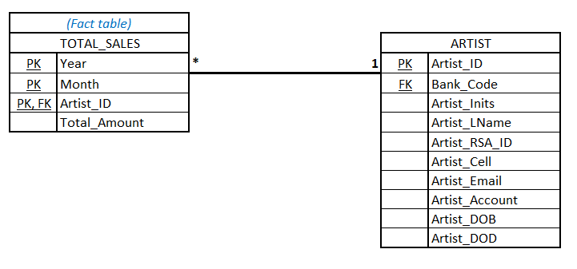

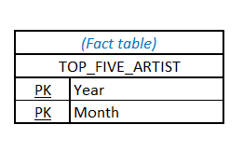
Required information scenario 2: Display the top 10 artist per year per month.
DIMENSION | DESCRIPTION | POSSIBLE ATTRIBUTES
Time  - Year  - Month | - Year and month don’t require additional dimension table | Shown in table below

Required information scenario 3: Display the top 5 devoted clients per year per month.
DIMENSION | DESCRIPTION | POSSIBLE ATTRIBUTES
Time  - Year  - Month | - Year and month don’t require additional dimension table | Shown in table below
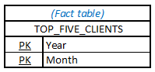

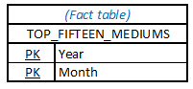
Required information scenario 4: Display the top 15 medium per year per month.
DIMENSION | DESCRIPTION | POSSIBLE ATTRIBUTES
Time  - Year  - Month | - Year and month don’t require additional dimension table | Shown in table below

Required information scenario 5: Display the top 5 delivery locations(city) per year per month.
DIMENSION | DESCRIPTION | POSSIBLE ATTRIBUTES
Time  - Year  - Month | - Year and month don’t require additional dimension table | Shown in table below
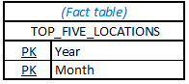

Required information scenario 6: Display the total income per year per month per artist.
DIMENSION | DESCRIPTION | POSSIBLE ATTRIBUTES
Time  - Year  - Month  Artist | - Year and month don’t require additional dimension table  - Artist required addition dimension table, because more info is required from artist than just the Artist_ID | Shown in table below
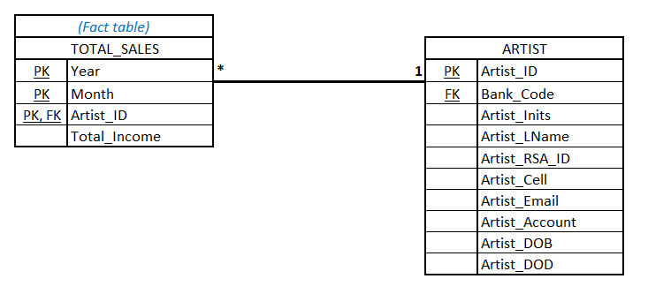

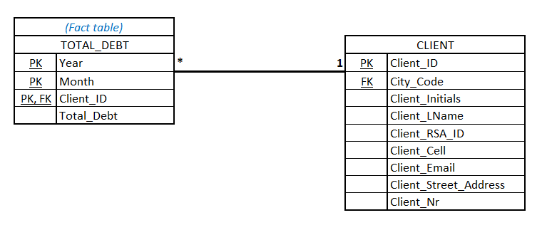
Required information scenario 7: Display the total debt per year per month per client.
DIMENSION | DESCRIPTION | POSSIBLE ATTRIBUTES
Time  - Year  - Month  Client | - Year and month don’t require additional dimension table  - Client required addition dimension table, because more info is required from artist than just the Client_ID | Shown in table below

Required information scenario 8: Display the total inventory per year per month per collection.
DIMENSION | DESCRIPTION | POSSIBLE ATTRIBUTES
Time  - Year  - Month  Collection | - Year and month don’t require additional dimension table  - Collection required addition dimension table, because more info is required from artist than just the Collection_ID | Shown in table below
